LINUX ESSENTIALS AND FILE MANAGEMENT
- Navigating the Filesystem
  - File Operations in Linux
  - Creating Directories
  - Copying, Moving, Renaming, and Deleting Files & Directories
- Using Pipes and Redirection
  - Redirection (>, >>)
  - Command Chaining (&&, ||)
- Process Management
  - Understanding Processes
  - Finding Process ID (PID)
- User & Group Management
  - Adding, Removing, and Modifying Users
  - Adding & Removing Groups
  - Setting Permissions (chmod, chown, umask)
- Disk Usage & Archiving
  - Checking Disk Usage (du, df)
  - Creating Archives (tar)
  - Compression (zip)
Navigating the Filesystem:
Linux is an essential skill for Data Engineer and DevOps professionals, providing powerful command-line tools to manage systems efficiently. This module covers fundamental Linux commands, user management, and advanced operations to help you navigate and control Linux-based environments seamlessly. Understanding the Linux directory structure and moving between folders is a fundamental skill for any DevOps engineer.
Let’s implement the commands:
- Ls Command:
- Open the Virtual Box & login to your ubuntu account you created.
- Then, Search for the Terminal:
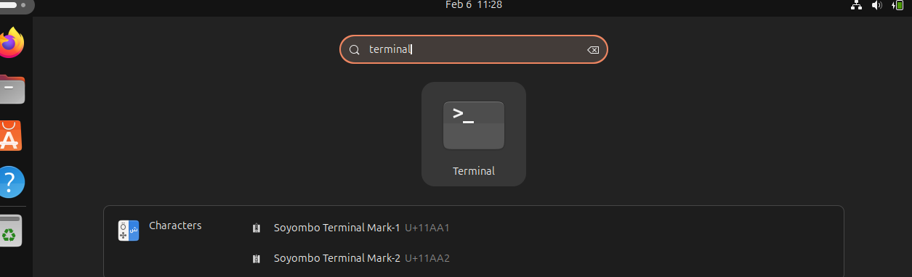
Now, type ls and press enter:
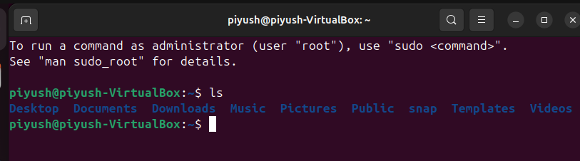
It will show up with the directories. (The “Piyush” is the username)

- Ls -l : This command will give a detailed information of a directory:
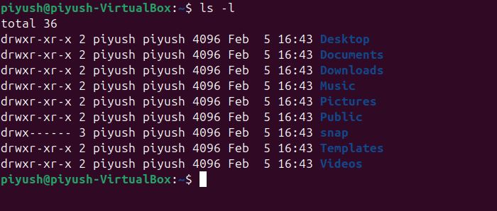
- Ls -la : This command will give detailed information about hidden files & directories.
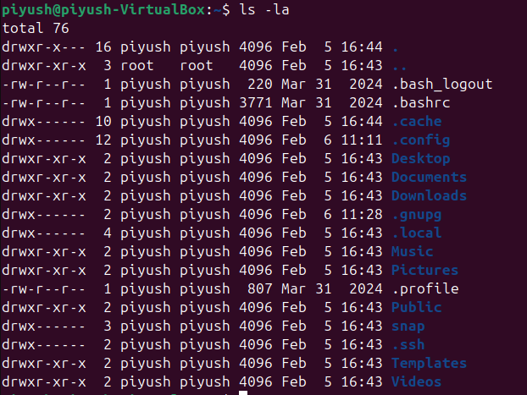
- Pwd: This command will show your present working directory.
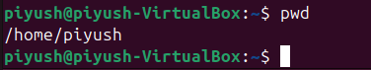
- Cd .. : This command will change the directory, and move to one level up
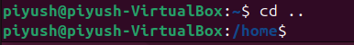
- Cd : This command will shift us back to the Home directory
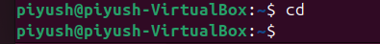
You can also open My Files:
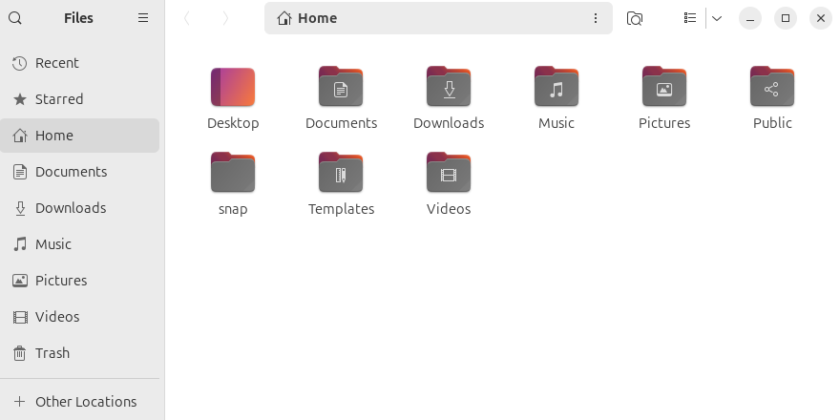
To See all the directories and the files.
File Operations in Linux
Managing files and directories is a fundamental aspect of working with Linux, especially for DevOps engineers who need to handle system configurations, backups, and automation efficiently. Below are key file operations that are commonly used in Linux.
Creating a file:
Touch: Touch command is used to create a file. Put the name of the file you want to, here we have used “file”.
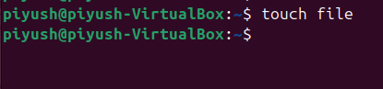
Result: Here you can see a file is created.
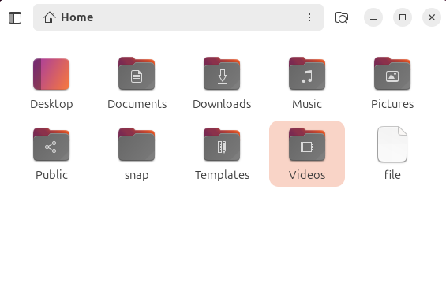
Now, let's create a file with some data.
Cat: The Cat command is used to create a file with data. Follow the below command and press Ctrl + z to save the file.
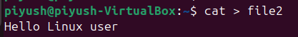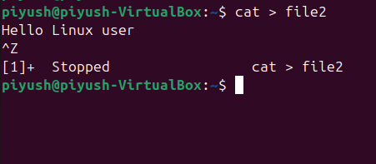
Now, you can see a new file with name file2 has been created.
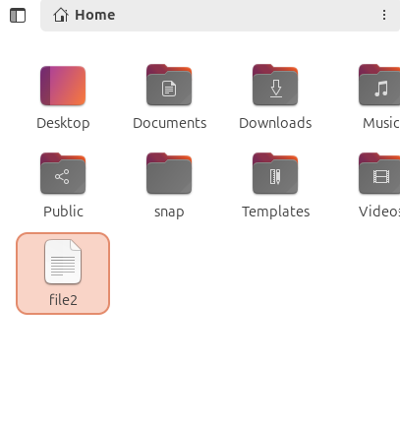
Open the file to see the content:
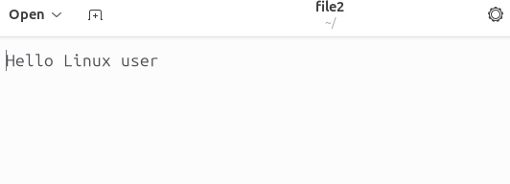
Now, to see what you have written in your file in the terminal, use the below command.
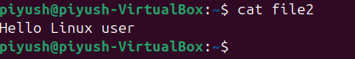
To Edit the data in Terminal from the file:
We will use the cat command along with >> then the file name. Now, we can add the text we want to add in the file, here we have used “This is my first program”. Then ctrl + z to save it.
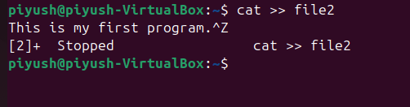
Now to check if the data is added into the file or not, use cat command and the filename.
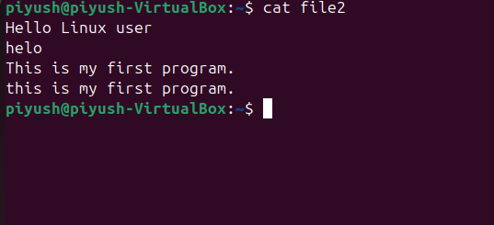
Creating Directory:
Now, we will see how to create a directory. To create a directory, mkdir command is used.
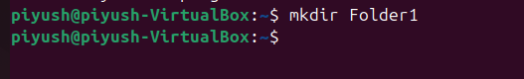
Here, you can see a new folder has been created.
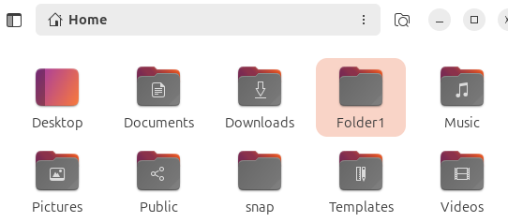
We can also create multiple directories, by just giving space to the directory name:
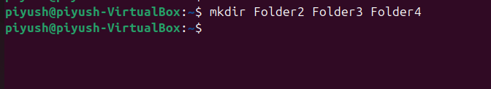
Result:
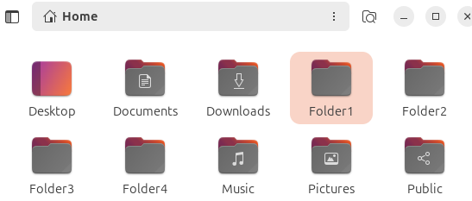
Copying a File:
Now, we will learn how to copy a file.
Above the white text are files & the blue texts are directories. Here we will copy the file “file2” and make a new file with the name “new”.
To Perform it we will use the “Cp command”.
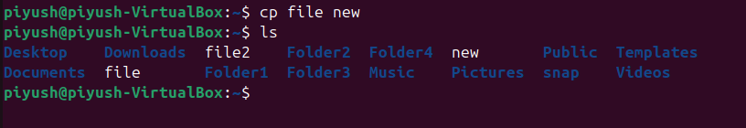
Here you can see a new file has been created with the name “new”.
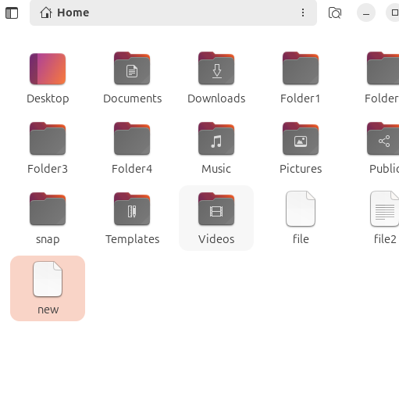
Now, let's copy a file to another directory.
To perform this operation, we will use the cp command in the following format:
cp file2 Folder1
Here:
- file2 is the name of the file to be copied.
- Folder1 is the destination directory.
However, if you encounter a "Permission denied" error, it means that administrative privileges are required to copy the file.
To resolve this, we will use the sudo command:
sudo cp file2 /Folder1
After running this command, you will be prompted to enter the user password. Once authenticated, the file will be copied successfully.
To verify, use the following command:
ls Folder1
This will display the contents of Folder1, confirming that file2 has been successfully copied.
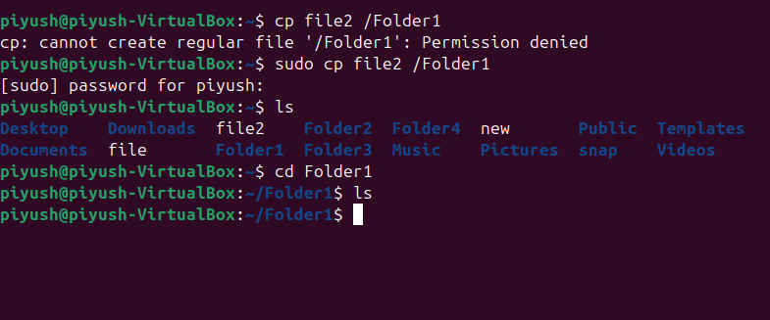
Moving Directory:
To move a directory to another Directory we will use mv command. Let’s move Folder1 to Folder2 in Linux Ubuntu, use the mv command:
mv Folder1 Folder2
Explanation:
- mv is the command used to move or rename files and directories.
- Folder1 is the directory you want to move.
- Folder2 is the destination directory.
If Permission Is Denied:
If you receive a "Permission denied" error, use sudo:
sudo mv Folder1 Folder2
After entering the user password, Folder1 will be moved inside Folder2. To verify, list the contents of Folder2:
ls Folder2
You should see Folder1 inside Folder2.
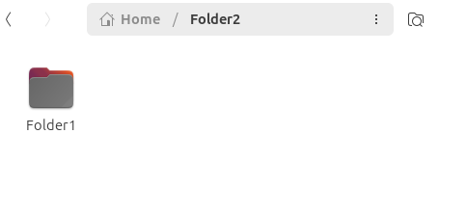
How to Delete a File:
To delete a file named file in Linux Ubuntu, use the rm command:
rm file
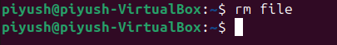
Explanation:
- rm (remove) is the command used to delete files.
- file is the name of the file you want to delete.
If Permission Is Denied:
If you receive a "Permission denied" error, use sudo:
sudo rm file
After entering the user password, the file will be deleted.
To Verify Deletion:
Run the following command:
ls
If the file is no longer listed, it has been successfully deleted.
How to Delete a Directory:
If the Directory Is Empty: Use the rmdir command:
rmdir Folder2
This will delete Folder2, but it only works if the directory is empty.
If the Directory Contains Files:
Use the rm -r command:
rm -r Folder2
Explanation:
- rm (remove) is used to delete files and directories.
- -r (recursive) ensures that all files and subdirectories inside Folder1 are also deleted.
To Verify Deletion: Run ls
ls
If Folder2 is no longer listed, it has been successfully removed.
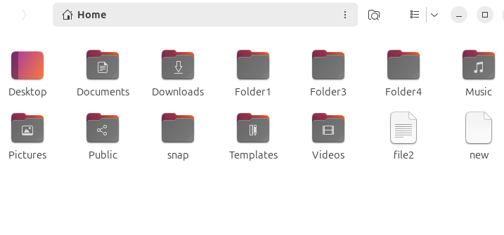
Renaming a File:
Let’s create a File:
touch File1
Now, let’s rename the file File1 to File2, using the mv command:
mv File1 File2
Explanation:
- mv is used to move or rename files and directories.
- File1 is the current name of the file.
- File2 is the new name you want to assign.
After entering the, File1 will be renamed to File2.
To Verify the Change:
Run:
ls
If File2 appears in the list instead of File1, the rename was successful.
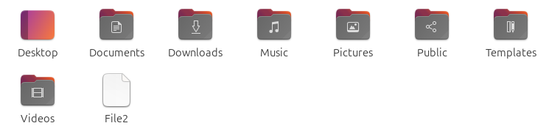
Renaming a Directory:
To rename a directory from Folder1 to Folder2 in Linux Ubuntu, use the mv command:
mv Folder1 Folder2
Explanation:
- mv is used to move or rename files and directories.
- Folder1 is the current name of the directory.
- Folder2 is the new name you want to assign.
To Verify the Change run:
ls
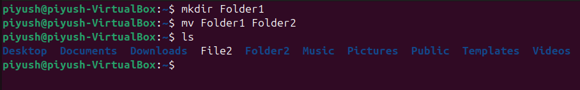
If Folder2 appears in the list instead of Folder1, the rename was successful.
How to Clear your Terminal:
Use Clear Command:
clear
The terminal is now clear.
Echo Command:
Display a line of text or variable value. Example: echo "Hello World!"
Echo "Hello World!"
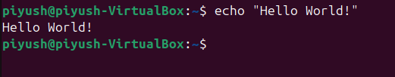
Advanced Commands
Uptime: Shows the uptime of the system.
uptime
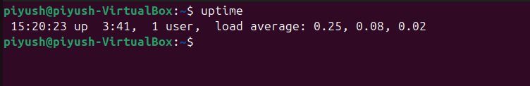
1. Using Pipes and Redirection
Linux allows you to manipulate data flow through pipes and redirection. These operations enable you to combine commands and work with data more efficiently.
Pipe (|)The pipe symbol (|) is used to send the output of one command directly into another command. This allows you to chain commands together to accomplish complex tasks.Example:
If we want specific data from httpd. We need to write the below command, and then filter out manually.
Ps -ef
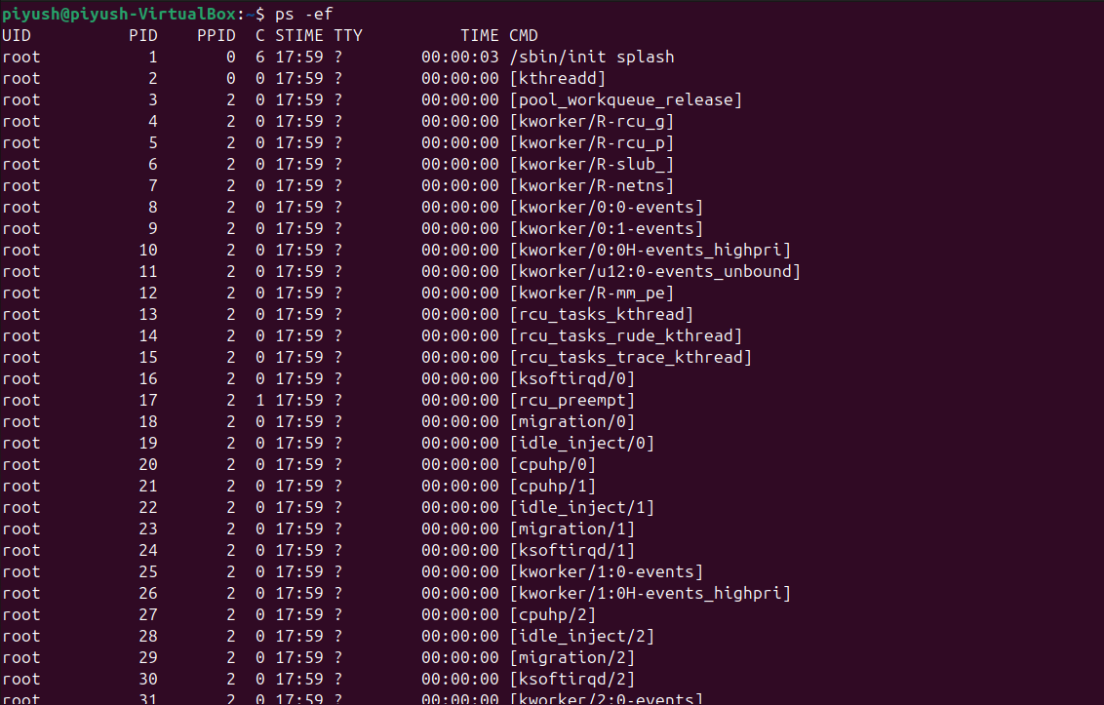
But if we use the Pipe Command along with it grep and the desired data i.e. httpd, then we will only see the data we want.
Ps -ef | grep httpd
Example for Pipe:
Q: Find out the number of files present in directories?
Ans: First we will use the command
pwd /etc
This will give us the directory details:
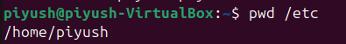
Now, put the ls command to get all the files name
ls
Now, put the command:
Ls -1
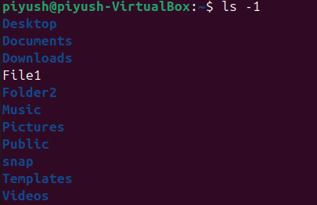
To get the list view of the files.
Now, write the same command by adding pipe | and wc (word count) with -l
Ls -1 | wc -l
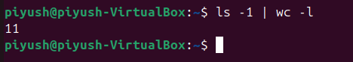
Hence, received the number of files 11 in the directory.
Redirection (>, >>):
Redirection allows you to control where the output of a command goes. By default, the output goes to the terminal. With redirection, you can send the output to a file or append it to an existing file.
>: Redirect output to a file (overwrites the file if it exists).Example:
echo "Hello, DevOps!" > greeting.txt
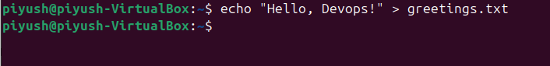
This will write "Hello, DevOps!" into the file greeting.txt. If greeting.txt already exists, it will be overwritten.
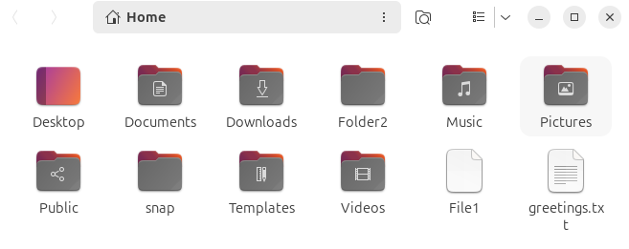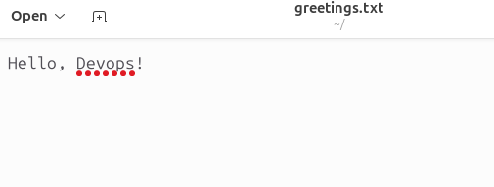
>>: Append output to a file (does not overwrite).Example:
echo "Learning advanced Linux commands" >> greeting.txt
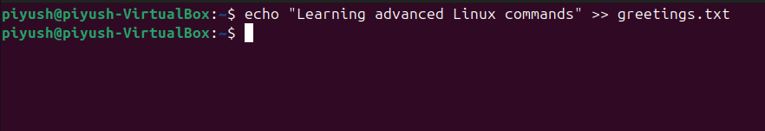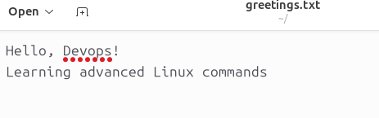
This will add the line to the end of greeting.txt without deleting any existing content.
2. Command Chaining with && and ||
Command chaining allows you to combine multiple commands into one line, enabling more complex and efficient workflows.
&& (AND)The && operator allows you to run a second command only if the first command is successful (i.e., returns a zero exit status).Example:
mkdir new_directory && cd new_directory
This command creates a directory named new_directory and then immediately changes into it, but only if the directory creation was successful.
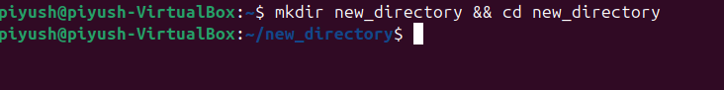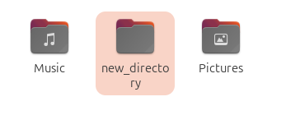
|| (OR)The || operator runs the second command only if the first command fails (i.e., returns a non-zero exit status).Example:
mkdir new_directory || echo "Failed to create directory"
If mkdir fails to create the directory, it will print "Failed to create directory" instead.
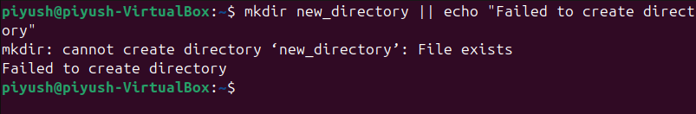
Combining && and ||You can combine both && and || to create complex logic in one line.Example:
mkdir new_directory && echo "Directory created!" || echo "Failed to create directory."
If the directory creation is successful, it will print "Directory created!" Otherwise, it will print "Failed to create directory."
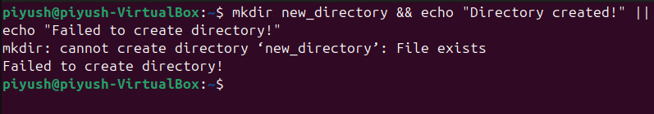
3. Understanding Process Management
As a DevOps engineer, you need to manage and monitor processes effectively. Here are some key commands for process management:
- ps (Process Status)
The ps command provides a snapshot of the currently running processes. It is typically used to check which processes are consuming resources.
Basic usage:
ps
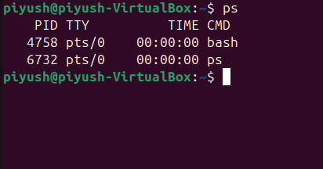
This shows processes running in the current terminal session.
To see all running processes:
ps aux
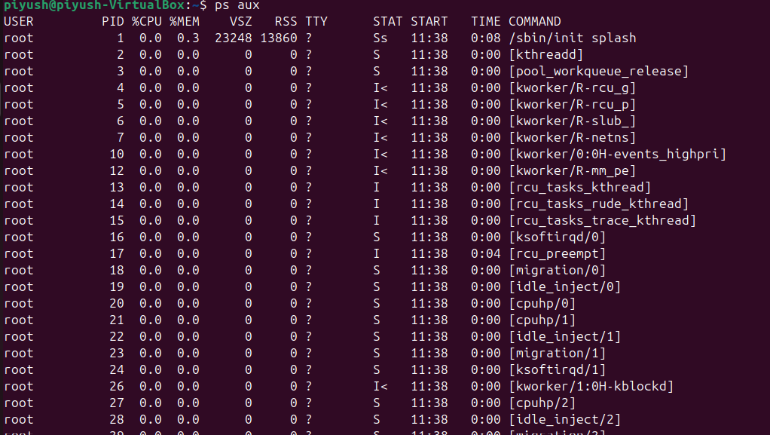
This will show all processes running on the system, including background processes.
To see processes by a specific user:
ps -u username
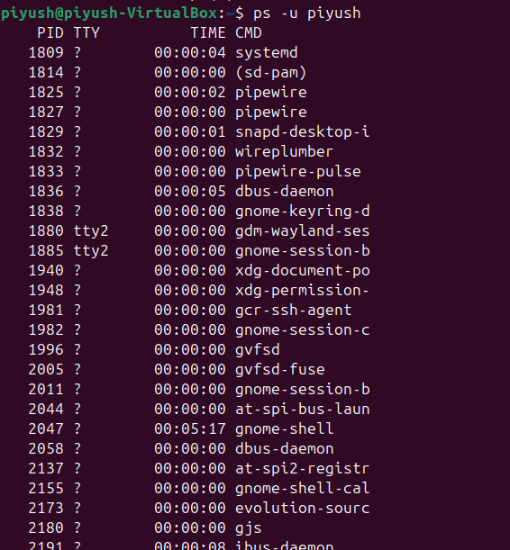
top (Task Manager)The top command provides a real-time, dynamic view of the system’s processes. It shows CPU usage, memory usage, and the status of running processes. Example:
top
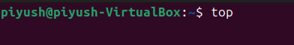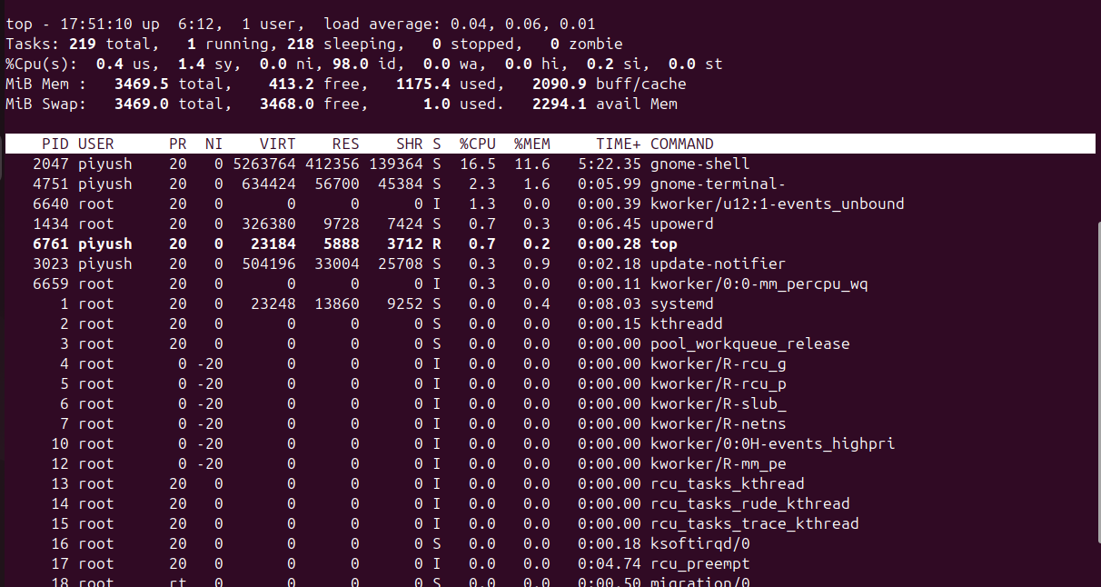
This command launches an interactive terminal window that updates in real-time, displaying resource-intensive processes.Key
keys in top:
- Press q to exit the top command.
- Press P to sort processes by CPU usage.
- Press M to sort processes by memory usage.
- kill (Terminate a Process): The kill command allows you to stop (terminate) a process by sending it a signal. You typically need the process ID (PID) to use kill.
To find the PID of a process, use: ps aux | grep process_name
Once you have the PID, you can stop the process with the kill command:
kill PID
To forcefully terminate a process, use the -9 signal:
kill -9 PID
Example:
kill 1234
This will terminate the process with PID 1234.
User and Group Management in Linux
Linux is a multi-user operating system that allows multiple users to access and operate the system simultaneously. Proper user and group management ensures security, access control, and efficient administration.
1. Managing Users and Groups
Adding a New User
To create a new user in Linux, use the adduser command:
sudo adduser username
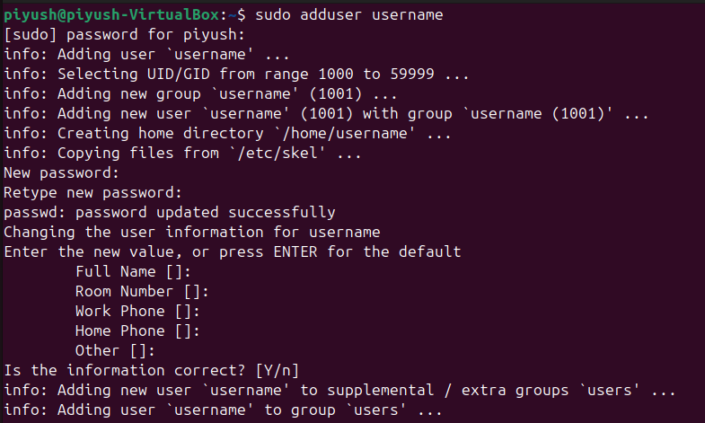
- The system will prompt you to enter a password and other details.
- This automatically creates a home directory for the user.
Removing a User
To delete a user from the system:
sudo deluser username
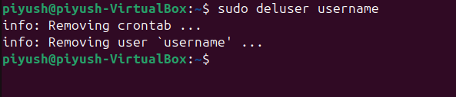
- If you also want to remove their home directory, use:
sudo deluser --remove-home username
Modifying a User
To modify an existing user's details, use the usermod command.
For example, to change a username:
sudo usermod -l new_username old_username
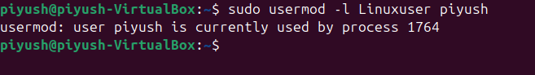
Then you can apply
Kill -9 1764
It will automatically logout if you entered your current username.
To change the home directory:
sudo usermod -d /new/home/directory -m username
Adding a New Group
To create a new group:
sudo groupadd groupname
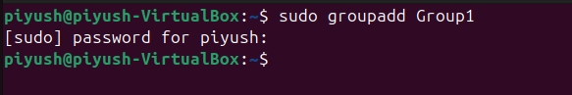
Adding a User to a Group
To add an existing user to a group:
sudo usermod -aG groupname username
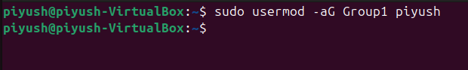
Removing a User from a Group
To remove a user from a group:
sudo deluser username groupname
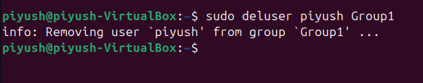
2. Setting Permissions: chmod, chown, umask
Understanding File Permissions
Each file and directory in Linux has three permission types:
- Read (r) → View file contents
- Write (w) → Modify file contents
- Execute (x) → Run the file as a program
Changing File Permissions: chmod
To modify file permissions, use chmod:
chmod 755 filename
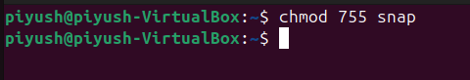
- 7 → Owner: Read (4) + Write (2) + Execute (1)
- 5 → Group: Read (4) + Execute (1)
- 5 → Others: Read (4) + Execute (1)
Changing File Ownership: chown
To change the owner of a file:
sudo chown new_owner filename
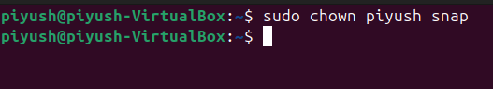
To change both owner and group:
sudo chown new_owner:new_group filename
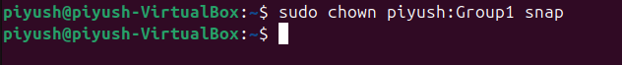
Setting Default Permissions: umask
umask defines the default permissions for newly created files. To check the current value:
umask
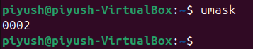
To change the default permission:
umask 022
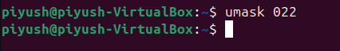
This ensures that new files are created with 755 permissions.
Best Practices for Managing Multi-User Environments
- Use Groups Efficiently: Assign users to groups instead of managing individual permissions.
- Limit Root Access: Use sudo for administrative tasks instead of logging in as root.
- Regularly Audit Users: Check active users and remove unnecessary accounts.
- Secure File Permissions: Restrict access to sensitive files using chmod and chown.
- Set Password Policies: Enforce strong password rules with passwd and chage commands.
Disk Usage Analysis: du, df
Check Disk Usage of Files and Directories (du)
To analyze disk usage for a specific directory:
du -sh /directory_name
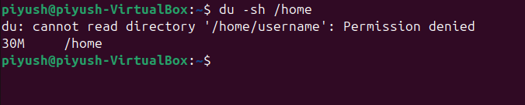
Here the disk usage size is 30MB
- -s → Shows total size.
- -h → Displays human-readable format (KB, MB, GB).
To list sizes of all subdirectories:
du -h --max-depth=1 /directory_name
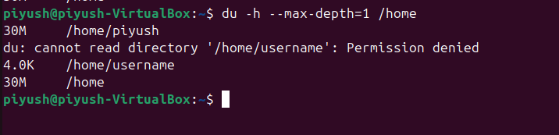
Check Available Disk Space (df)
To check the free space on all mounted filesystems:
df -h
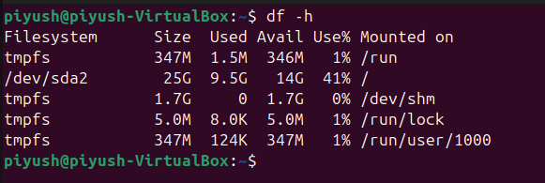
- -h → Displays human-readable format.
To check space used by a specific partition:
df -h /dev/sda1
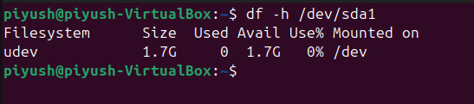
3. Archiving and Compression
Create an Archive (tar)
To create a .tar archive:
tar -cvf archive_name.tar directory_name/
- -c → Create archive.
- -v → Verbose (shows progress).
- -f → Specify archive file name.
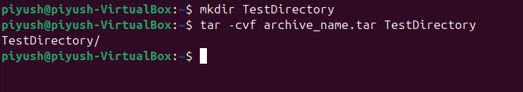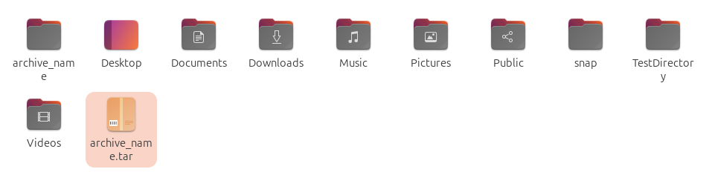
Extract an Archive
tar -xvf archive_name.tar
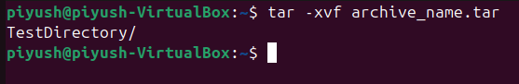
- -x → Extract files.
Compress a File using gzip
gzip filename
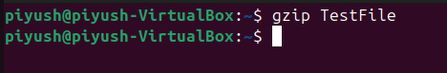
This creates filename.gz.
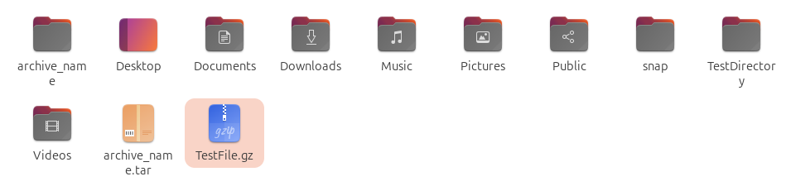
To decompress:
gunzip filename.gz
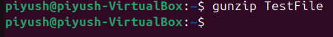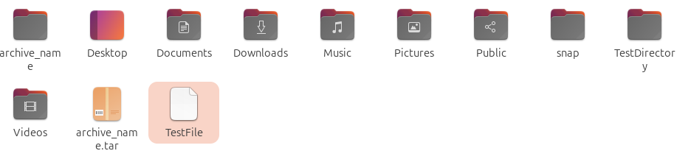
Compress a File using zip
zip archive_name.zip filename
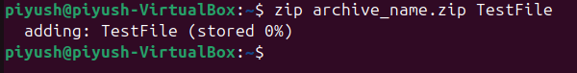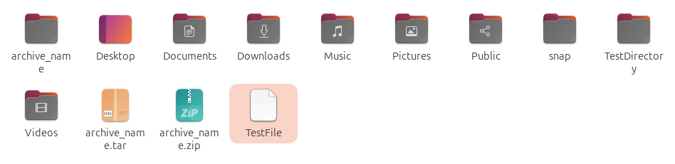
To unzip:
unzip archive_name.zip
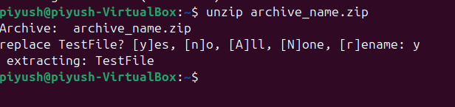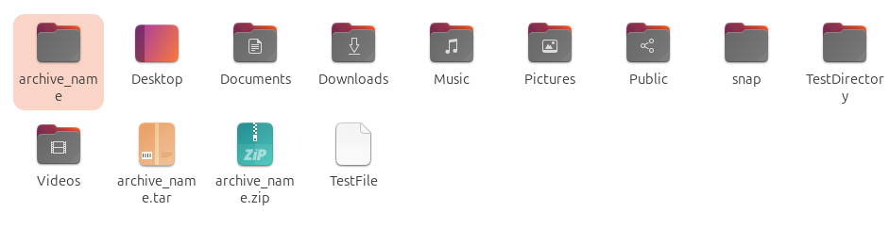
4. Linux Volume Management
Partitioning Disks
List available disks and partitions:
lsblk
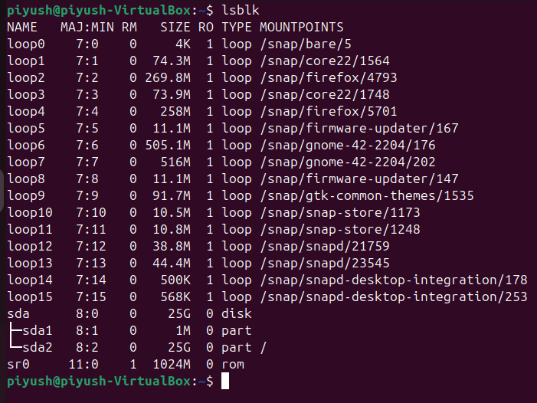
Create a new partition using fdisk:
sudo fdisk /dev/sdx
- Press n to create a new partition.
- Press w to save changes.
Format the partition:
sudo mkfs.ext4 /dev/sdx1
Mount the partition:
sudo mount /dev/sdx1 /mnt
Managing Storage Volumes with Logical Volume Manager (LVM)
1. Create a Physical Volume (PV)
sudo pvcreate /dev/sdx1
2. Create a Volume Group (VG)
sudo vgcreate my_vg /dev/sdx1
3. Create a Logical Volume (LV)
sudo lvcreate -L 10G -n my_lv my_vg
4. Format and Mount the Logical Volume
Format the Logical Volume:
sudo mkfs.ext4 /dev/my_vg/my_lv
Mounting the logical Volume:
sudo mount /dev/my_vg/my_lv /mnt
Best Practices for File and Storage Management
- Regularly monitor disk usage using du and df.
- Organize files into directories and use meaningful names.
- Backup important data using tar and zip.
- Use LVM for efficient storage management and flexibility.
- Remove unused files and directories to free up space.

